**TUGAS PRAKTIKUM**

**PRAKTIKUM PAW**

**MODUL 3 “PHP Forms”**



|  |
| --- |
| **Disusun Oleh:**  Nama: Fikri Ainun Najib  NIM:200411100153  Kelas: PAW B  **Dosen Pengampu:**  Nama: Ach. Khozaimi, S.Kom., M.Kom  NIP: 19860926 201404 1 001  **Asisten Praktikum:**  Nama: Alief Fadhilah Athallariq  NIM: 180411100028 |

**PRODI TEKNIK INFORMATIKA**

**JURUSAN TEKNIK INFORMATIKA  
FAKULTAS TEKNIK**

**UNIVERSITAS TRUNOJOYO MADURA**

**2022**

1. **Soal:** Buatlah sebuah form yang berisi name, e-mail, website, comment, gender, tombol submit, dan tampilan output dari inputan yang dimasukkan seperti berikut:

**Source Code:**

|  |
| --- |
| <span>* Required field</span><br><br>  <form action="#" method="post" id="form">  <label for="name">Name : </label>  <input type="text" name="name" placeholder="Name" value=<?php if(isset($name)) echo "$name" ?> >  <span><?php echo (strlen($nameErr)>0)? " $nameErr" : " *" ?> </span><br><br>  <label for="email">Email : </label>  <input type="text" name="email" placeholder="Email" value=<?php if(isset($email)) echo "$email" ?>>  <span> <?php echo (strlen($emailErr)>0)? " $emailErr" : " *" ?></span><br><br>  <label for="website">Website : </label>  <input type="text" name="website" placeholder="website" value=<?php if(isset($website)) echo "$website" ?>>  <span><?php echo (strlen($websiteErr)>0)? " $websiteErr" : "" ?></span><br><br>  <label for="comment">Comment : </label>  <textarea name="comment" id="comment" form="form" cols="30" rows="5" placeholder="Comment"><?php if(isset($comment)) echo "$comment" ?></textarea><br><br>  <label for="gender">Gender : </label>  <input type="radio" id="female" name="gender" <?php if (isset($gender) && $gender=="female") echo "checked";?> value="female">  <label for="female">Female</label>  <input type="radio" id="male" name="gender" <?php if (isset($gender) && $gender=="male") echo "checked";?> value="male">  <label for="male">Male</label>  <input type="radio" id="other" name="gender" <?php if (isset($gender) && $gender=="other") echo "checked";?> value="other">  <label for="other">Other</label><span><?php echo (strlen($genderErr)>0)? " $genderErr" : " *" ?></span><br><br>  <input type="submit" name="submit" value="Submit">  </form>  <h1>Your Input : </h1> |

**Screenshoot:**

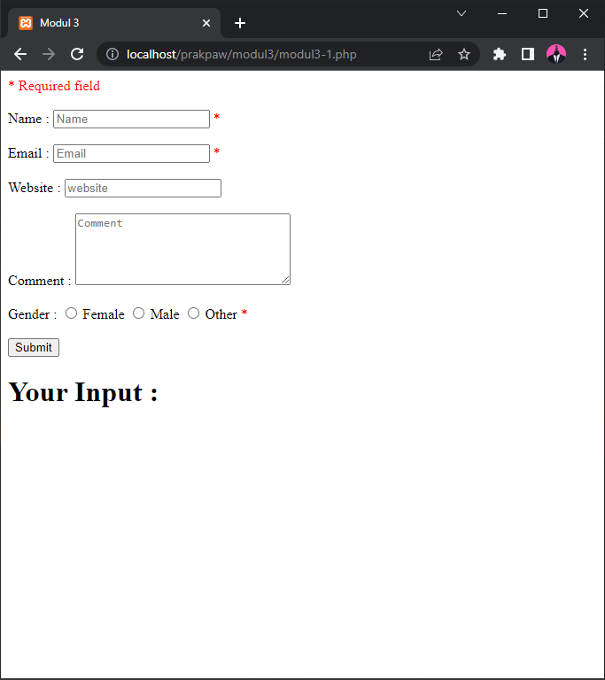

1. **Soal:** Buatlah validasi terhadap form, apabila form disubmit dalam keadaan kosong maka akan muncul pesan seperti berikut:

**Source Code:**

|  |
| --- |
| if(strlen($_POST['name']) == 0){  $nameErr = " *Name is required";  }  if(strlen($_POST['email']) == 0){  $emailErr = " *Email is required";  }    if(empty($_POST['gender'])){  $genderErr = " *gender is required";  }?> |

**Screenshoot:**

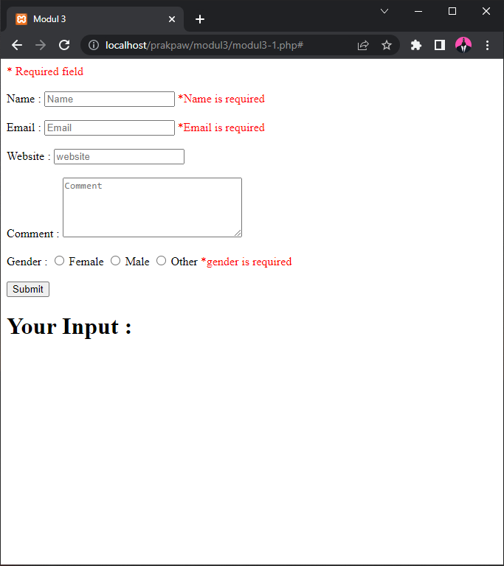

1. **Soal:** Berikan validasi terhadap kesalahan input pada name, e-mail dan website, seperti contoh berikut:

**Source Code:**

|  |
| --- |
| $nameErr = $emailErr = $genderErr = $websiteErr = $commentErr ="";  if(isset($_POST['submit'])){  if(strlen($_POST['name']) == 0){  $nameErr = " *Name is required";  }else if(!preg_match("/^[a-zA-Z ]*$/",$_POST['name'])){  $nameErr = " *Only letters and white space allowed";  }else{  $name = $_POST['name'];  }  if(strlen($_POST['email']) == 0){  $emailErr = " *Email is required";  }else if(!filter_var($_POST['email'],FILTER_VALIDATE_EMAIL)){  $emailErr = " *Invalid email format";  }else{  $email = $_POST['email'];  }  if(strlen($_POST['website']) == 0){  $website = $_POST['website'];  }else if(!preg_match("/\b(?:(?:https?|ftp):\/\/|www\.)[-a-z0-9+&@#\/%?=~_|!:,.;]*[-a-z0-9+&@#\/%=~_|]/i",$_POST['website'])){  $websiteErr = " *Invalid URL format";  }else{  $website = $_POST['website'];  }  if(empty($_POST['gender'])){  $genderErr = " *gender is required";  }else{  $gender = $_POST['gender'];  }  $comment = $_POST['comment'];  } |

**Screenshoot:**

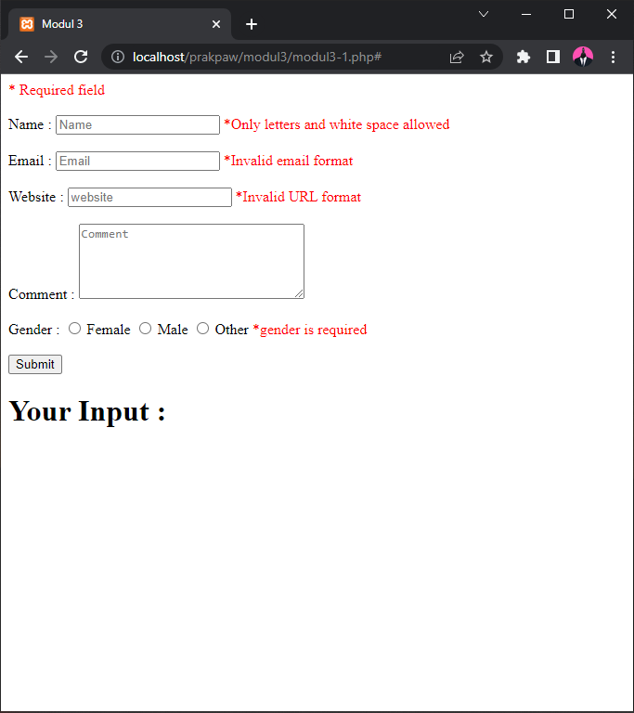

1. **Soal:** Berikan kondisi pada form apabila dilakukan submit maka value yang diinputkan pada field tidak hilang

**Source Code:**

|  |
| --- |
| <?php  #get data from form  $nameErr = $emailErr = $genderErr = $websiteErr = $commentErr ="";  if(isset($_POST['submit'])){  if(strlen($_POST['name']) == 0){  $nameErr = " *Name is required";  }else if(!preg_match("/^[a-zA-Z ]*$/",$_POST['name'])){  $nameErr = " *Only letters and white space allowed";  }else{  $name = $_POST['name'];  }  if(strlen($_POST['email']) == 0){  $emailErr = " *Email is required";  }else if(!filter_var($_POST['email'],FILTER_VALIDATE_EMAIL)){  $emailErr = " *Invalid email format";  }else{  $email = $_POST['email'];  }  if(strlen($_POST['website']) == 0){  $website = $_POST['website'];  }else if(!preg_match("/\b(?:(?:https?|ftp):\/\/|www\.)[-a-z0-9+&@#\/%?=~_|!:,.;]*[-a-z0-9+&@#\/%=~_|]/i",$_POST['website'])){  $websiteErr = " *Invalid URL format";  }else{  $website = $_POST['website'];  }  if(empty($_POST['gender'])){  $genderErr = " *gender is required";  }else{  $gender = $_POST['gender'];  }  $comment = $_POST['comment'];  }  ?>  <!DOCTYPE html>  <html lang="en">  <head>  <meta charset="UTF-8">  <meta http-equiv="X-UA-Compatible" content="IE=edge">  <meta name="viewport" content="width=device-width, initial-scale=1.0">  <title>Modul 3</title>  <style>  span{  color: red;  }  </style>  </head>  <body>  <span>* Required field</span><br><br>  <form action="#" method="post" id="form">  <label for="name">Name : </label>  <input type="text" name="name" placeholder="Name" value=<?php if(isset($name)) echo "$name" ?> >  <span><?php echo (strlen($nameErr)>0)? " $nameErr" : " *" ?> </span><br><br>  <label for="email">Email : </label>  <input type="text" name="email" placeholder="Email" value=<?php if(isset($email)) echo "$email" ?>>  <span> <?php echo (strlen($emailErr)>0)? " $emailErr" : " *" ?></span><br><br>  <label for="website">Website : </label>  <input type="text" name="website" placeholder="website" value=<?php if(isset($website)) echo "$website" ?>>  <span><?php echo (strlen($websiteErr)>0)? " $websiteErr" : "" ?></span><br><br>  <label for="comment">Comment : </label>  <textarea name="comment" id="comment" form="form" cols="30" rows="5" placeholder="Comment"><?php if(isset($comment)) echo "$comment" ?></textarea><br><br>  <label for="gender">Gender : </label>  <input type="radio" id="female" name="gender" <?php if (isset($gender) && $gender=="female") echo "checked";?> value="female">  <label for="female">Female</label>  <input type="radio" id="male" name="gender" <?php if (isset($gender) && $gender=="male") echo "checked";?> value="male">  <label for="male">Male</label>  <input type="radio" id="other" name="gender" <?php if (isset($gender) && $gender=="other") echo "checked";?> value="other">  <label for="other">Other</label><span><?php echo (strlen($genderErr)>0)? " $genderErr" : " *" ?></span><br><br>  <input type="submit" name="submit" value="Submit">  </form>  <h1>Your Input : </h1>  <?php  #check if $name isset  if(isset($name,$email,$website,$gender)){  echo "<p>Name : $name</p>";  echo "<p>Email : $email</p>";  echo "<p>Website : $website</p>";  echo "<p>Comment : $comment</p>";  echo "<p>gender : $gender</p>";  }  ?>  </body>  </html> |

**Screenshoot:**

